TRIGGERS AND CURSOR

HU22CSEN0100287

Sai Ganesh Eswaraprasad

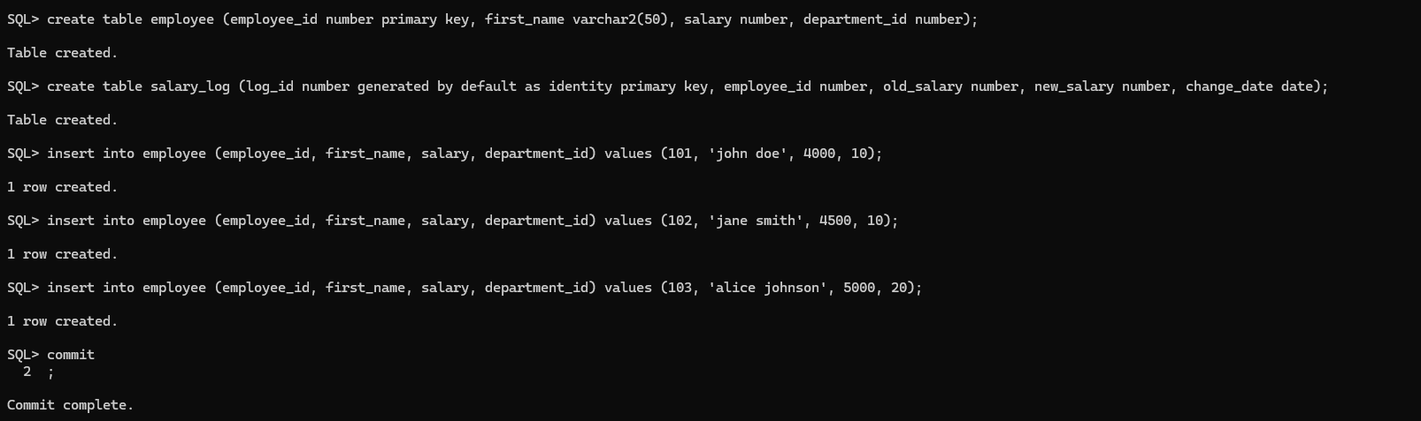

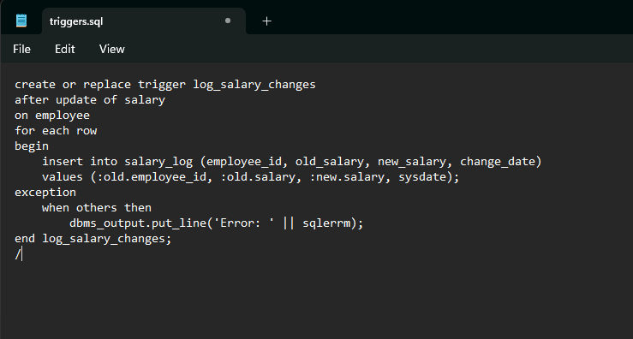

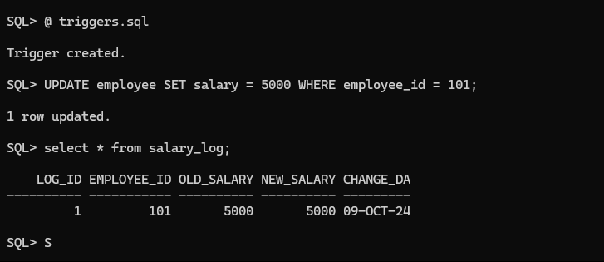

CURSOR



